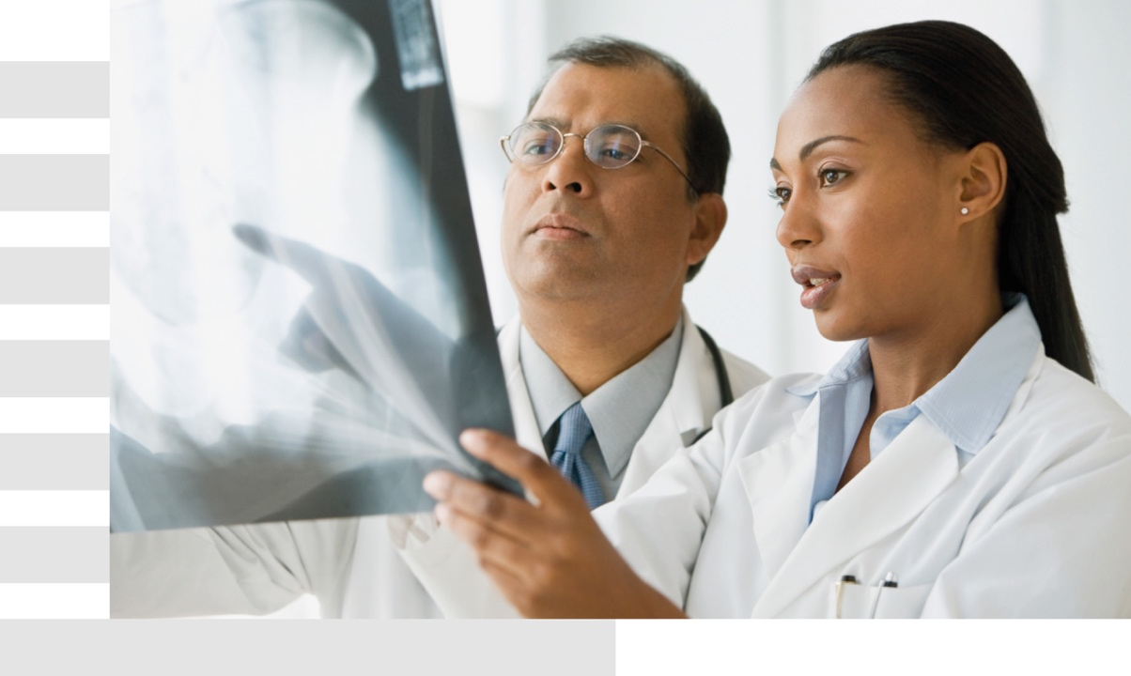

Agenda | December 18-19, 2018

Capio Fundacion Himenez Diaz, Avda. Reyes. Catolicos 2, 28040 Madrid

Shoulder Arthroscopy Course (visitation to Dr Calvo)

Day 1 |  | December 18 | , 2018
08:30 | Shuttle to the medical centre
08:45 | Welcome and Overview of medical centre,  preoperative planning |  | Dr Calvo
09:00 | 1st shoulder arthroscopy surgery |  | Dr Calvo
12:30 | Case studies and Q&A session |  | Dr Calvo
13:30 | Lunch
14:30 | 2nd shoulder arthroscopy surgery |  | Dr Calvo
18:00 | Q&A session |  | Dr Calvo

Day 2 |  |  | December 19, 2018
07:30 | Breakfast in the hotel
08:30 | Shuttle to the medical centre
08:45 | Preoperative planning |  | Dr Calvo
09:00 | 3rd shoulder arthroscopy surgery |  | Dr Calvo
12:30 | Case studies and Q&A session |  | Dr Calvo
13:30 | Lunch
14:30 | 4th shoulder arthroscopy surgery |  | Dr Calvo
18:00 | Q&A session |  | Dr Calvo
www.jnj.com / www.depuysynthes.com / www.esi-online.de
EMEA HCC: [XXXXXXXXX] (NB: Local HCC approval for attending delegates must be obtained separately)
EMEA HCC: [XXXXXXXXX] (NB: Local HCC approval for attending delegates must be obtained separately)

