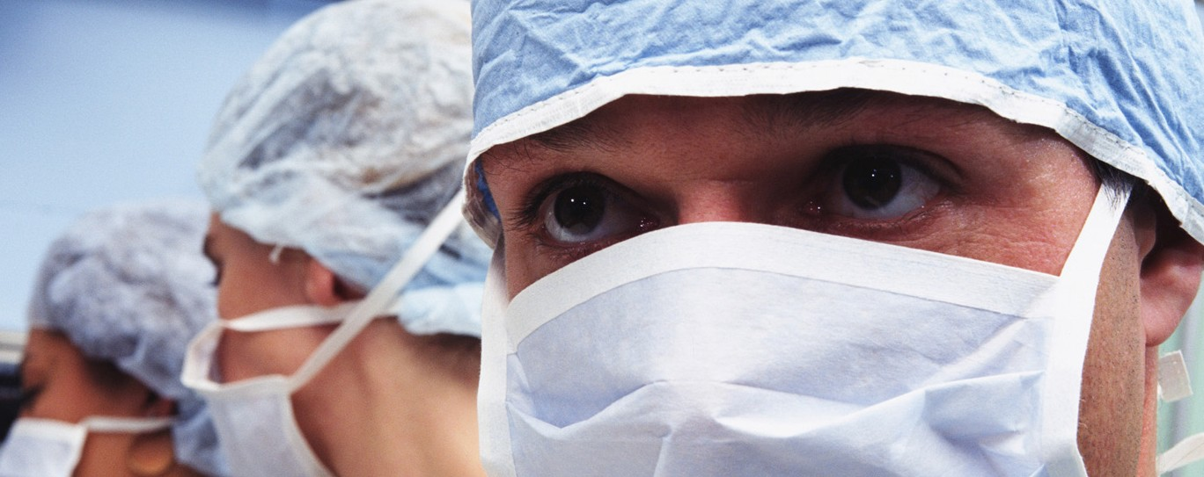



**General Shoulder Arthroscopy**

**November 8, 2017**

07.30 - 08.15 Breakfast in the hotel

08.30 - 08.45 Shuttle to the medical centre

08.45 - 09.00 Welcome and Overview of medical centre, preoperative planning

09.00 - 12.00 1st shoulder arthroscopy surgery

12.00 - 13.00 Case studies and Q&A session

13.00 - 14.00 Lunch

14.00 - 17.00 2nd shoulder arthroscopy surgery

17.00 - 18.00 Q&A session

**November 9, 2017**

07.30 - 08.15 Breakfast in the hotel

08.30 - 08.45 Shuttle to the medical centre

08.45 - 09.00 Preoperative planning

09.00 - 12.00 3rd shoulder arthroscopy surgery

12.00 - 13.00 Case studies and Q&A session

13.00 - 14.00 Lunch

14.00 - 17.00 4th shoulder arthroscopy surgery

17.00 - 18.00 Q&A session



[Northway medicinos centras](http://www.klaipeda.nmc.lt/)

**November 8-9, 2017**

**Northway medical**

**centre,**

**J.Basanavičiaus g. 80,**

**Kretinga, Lithuania**

**Dr.Viktoras**

**Jermolajevas**

